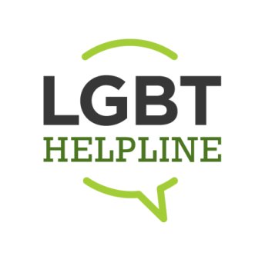

VOLUNTEER APPLICATION FORM
The LGBT Helpline is run through a network of local helpline centres. Once completed your application form will be reviewed and submitted to the volunteer coordinator in the centre nearest you. Information is dealt with in the strictest of confidence.

Surname _______________________________ Forename ____________________________________
Address _______________________________ Mobile No. _____________________________________
_______________________________ E-Mail Address _________________________________
________________________________

Are you aged 18+ 

Where did you hear about volunteering opportunities within the LGBT Helpline? Please specify.

Radio  Television   Newspaper   Posters/Billboards 

LGBT Website  Facebook  Twitter   Volunteer Centre 

Friends/Family   Volunteers  Staff  Online Advertising  

Have you previously applied to volunteer with the LGBT Helpline? YES  NO 

What do you hope to gain from the volunteering experience with the LGBT Helpine? _________________

Please tell us about any educational background, work or volunteering experience that would be relevant to the volunteer role you are applying for.

Garda Vetting is a requirement for all volunteer roles associated with the LGBT helpline, do you agree to be vetted as part of the recruitment process: YES   NO 

When are you available to volunteer? (Please specify days, times etc.) _____________________________
References:
Please supply us with the details of 2 referees (Personal friends or relatives will not be accepted)

Name | Name
Address | Address
Email | Email
Mobile | Mobile
Nature of Relationship | Nature of Relationship

FOR OFFICE USE ONLY
Date Application Form Received
Date of Information Night Attended
Information Night Facilitated by
Reason Not Shortlisted
Date of Interview
Interviewers
Result of Interview
Date Training Course Commenced

